Task1:

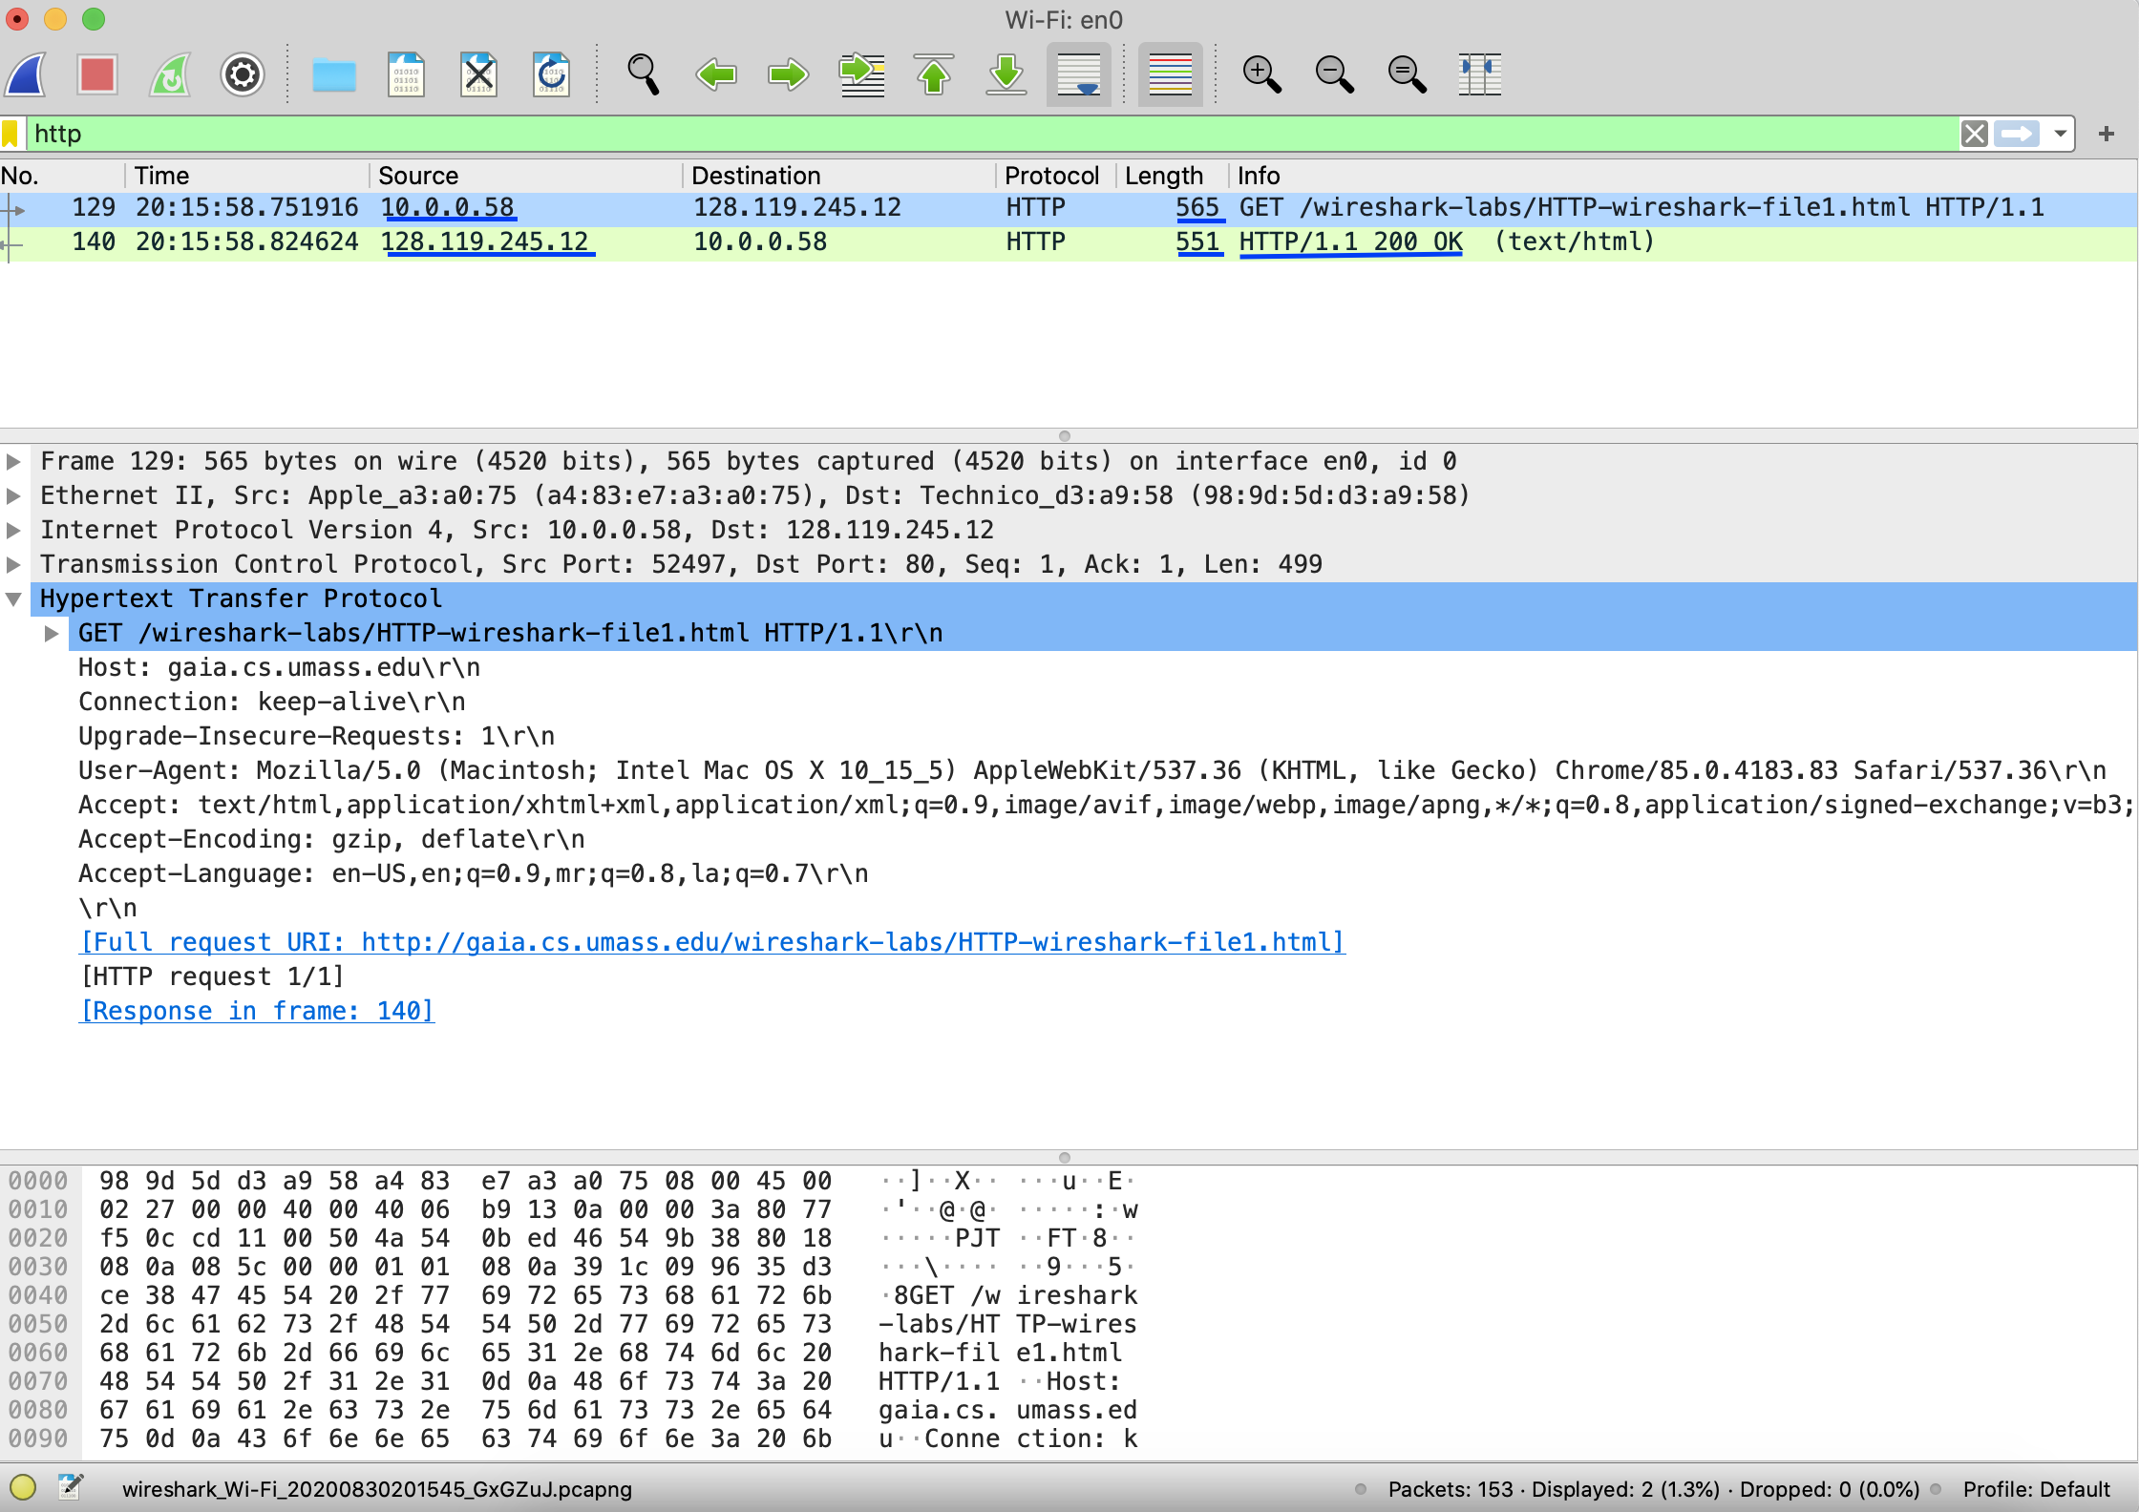

A1.

The IP address of my laptop is: 10.0.0.58

The IP address of *gaia.cs.umass.edu* server is 128.119.245.12

A2.

The status code returned is 200 and the phrase returned is “OK”.

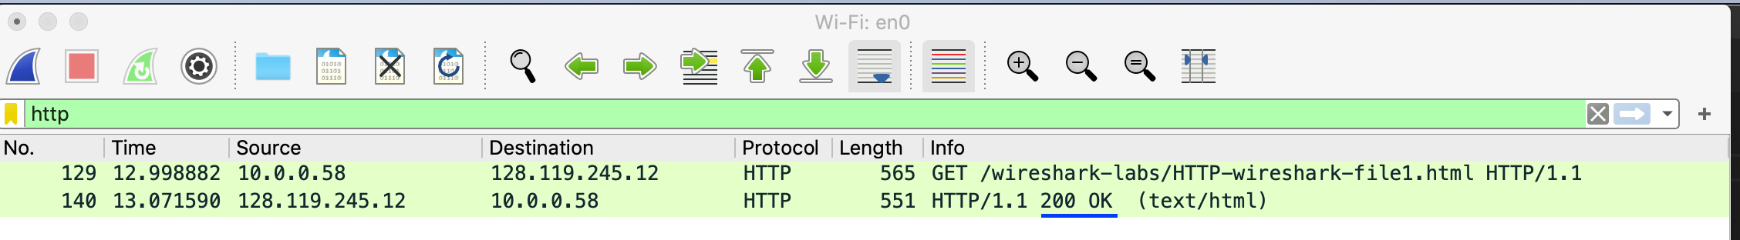

A3.

The language is English and English-US. It can be found in the header of the HTTP Request send to the server. The line is Accept-Language in the Header. I have highlighted it in the screenshot below.

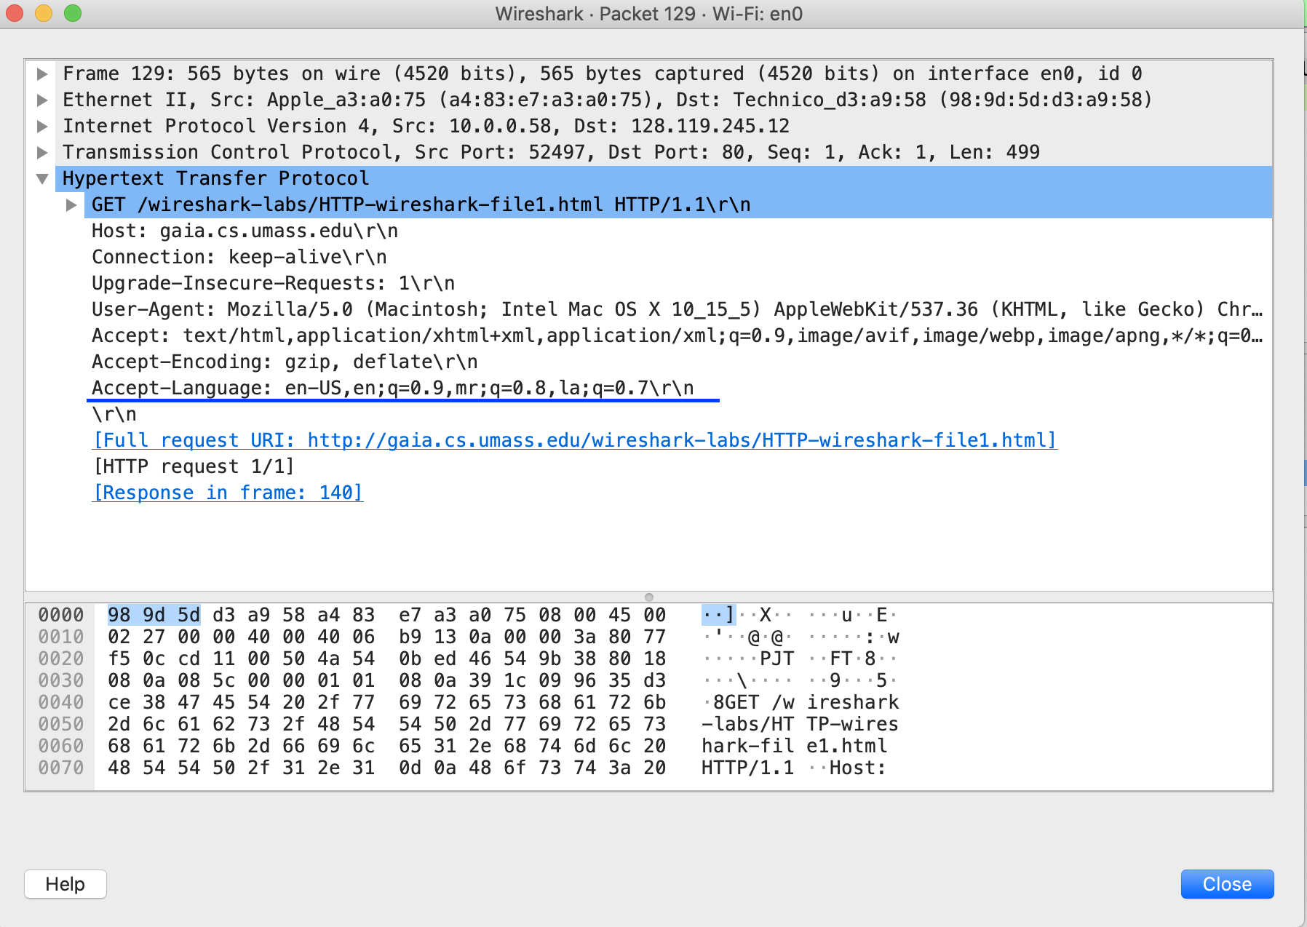

A4.

128 bytes of content are returned to the browser. The header line used to indicate it is Content-Length.

I have highlighted it in the screenshot.

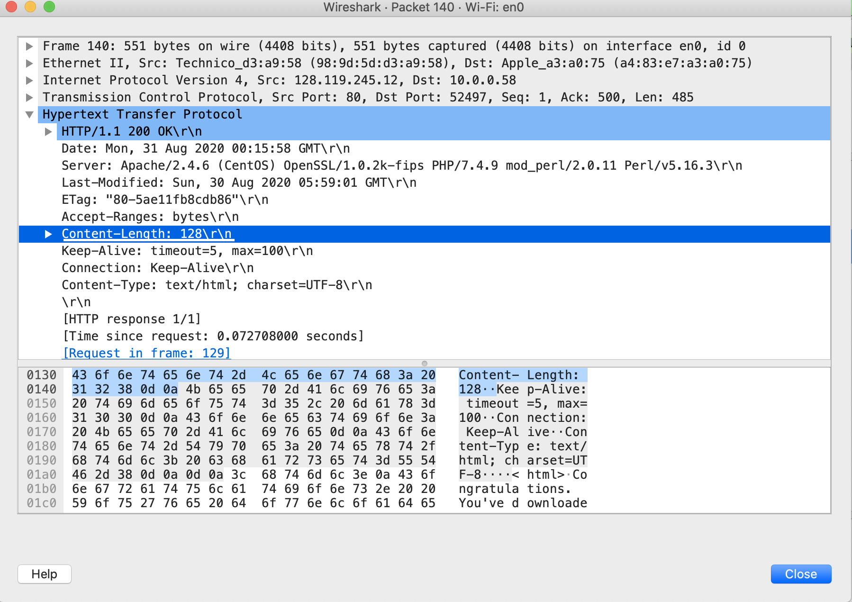

A5.

It took 0.072708 seconds.

Task2:

A1.

